4.2: Navigation

4.2.1: Tests performed

All tests performed use normal data (a button press).

The menus, as well as the “Select Color”, “Open...”, “Save As...” and “Print” dialogs, are produced by the framework, so they are not included in the test results. However, the functionality of each button in each menu and the custom widgets needs to be programmed so each button must be included in the test results.

Two tests are added here for the new Undo and Redo buttons.

The “File” menu

|  |  |  |  |
| --- | --- | --- | --- |
| Test number | Description | Result | Cross-reference |
| 1 | On clicking “New” | Pass | Figure 4.2.1 |
| 1a) | On clicking “Yes” in popup box | Partial fail – see section 4.2.2 | Figure 4.2.2 |
| 1b) | On clicking “No” in popup box | Pass | Figure 4.2.3 |
| 2 | On clicking “Open” | Pass | Figure 4.2.4 |
| 3 | On clicking “Save” | Pass | Figure 4.2.5 |
| 4 | On clicking “Save as” | Pass | Figure 4.2.6 |
| 5 | On clicking “Print” | Pass | Figure 4.2.7 |
| 6 | On clicking “Exit” | Pass | Figure 4.2.8 |

The “Options” menu

|  |  |  |  |
| --- | --- | --- | --- |
| Test number | Description | Result | Cross-reference |
| 7 | On clicking “Edit Conditions” | Pass | Figure 4.2.9 |
| 7a) | On clicking “Cancel” in “Edit Conditions” dialog | Pass | Figure 4.2.10 |
| 7b) | On clicking “OK” in “Edit Conditions” dialog (with invalid data) (“Students attempt to balance equation” unchecked) | Pass | Figure 4.2.11 |
| 7b)i) | On clicking “OK” in “Invalid Data” dialog | Fail – see section 4.2.2 | Figure 4.2.12 |
| 7c) | On clicking “OK” in “Edit Conditions” dialog (with invalid data) (“Students attempt to balance equation” checked) | Pass | Figure 4.2.13 |
| 7d) | On clicking “OK” in “Edit Conditions” dialog (with valid data) (“Students attempt to balance equation” unchecked) | Pass | Figure 4.2.14 |
| 7e) | On clicking “OK” in “Edit Conditions” dialog (with valid data) (“Students attempt to balance equation” checked) | Pass | Figure 4.2.15 |
| 7e)i) | On clicking “OK” in “Balance Equation” dialog | Pass | Figure 4.2.16 |

The “About” menu

|  |  |  |  |
| --- | --- | --- | --- |
| Test number | Description | Result | Cross-reference |
| 8 | On clicking “Version [version]” | Pass | Figure 4.2.17 |

The reaction windows

The buttons which appear for the left and right reaction viewing widgets function exactly the same way, so only the results for the buttons in the left widget are included.

|  |  |  |  |
| --- | --- | --- | --- |
| Test number | Description | Result | Cross-reference |
| 9 | On clicking “Set reactant colour” | Pass | Figure 4.2.18 |
| 10 | On clicking “Set product colour” | Pass | Figure 4.2.19 |
| 11 | On clicking “Concentration Graphs” | Pass | Figure 4.2.20 |
| 12 | On clicking “Rate Graphs” | Pass | Figure 4.2.21 |
| 13 | On clicking “Close” in “Compare Graphs” window | Pass | Figure 4.2.22 |
| 14 | On clicking “Calculate Kc” | Pass | Figure 4.2.23 |
| 15 | On clicking “Show working” | Pass | Figure 4.2.24 |
| 16 | On clicking “Start animation” | Pass | Figure 4.2.25 |
| 17 | On clicking “Compare reaction” | Pass | Figure 4.2.26 |
| 18 | On clicking “+” (open tab) button | Pass | Figure 4.2.27 |
| 19 | On clicking “X” (close tab) button when only 1 reaction in file | Pass | Figure 4.2.28 |
| 20 | On checking / unchecking “Show data” box | Pass | Figure 4.2.29 |

Additional tests

|  |  |  |  |  |
| --- | --- | --- | --- | --- |
| Test number | Description | Expected result | Actual result | Cross-reference |
| 21 | On clicking “Undo” in Options menu | Cancels last changes made to reaction | Pass | Figure 4.2.30 |
| 22 | On clicking “Redo” in Options menu | Restores cancelled changes to last reaction | Pass | Figure 4.2.31 |

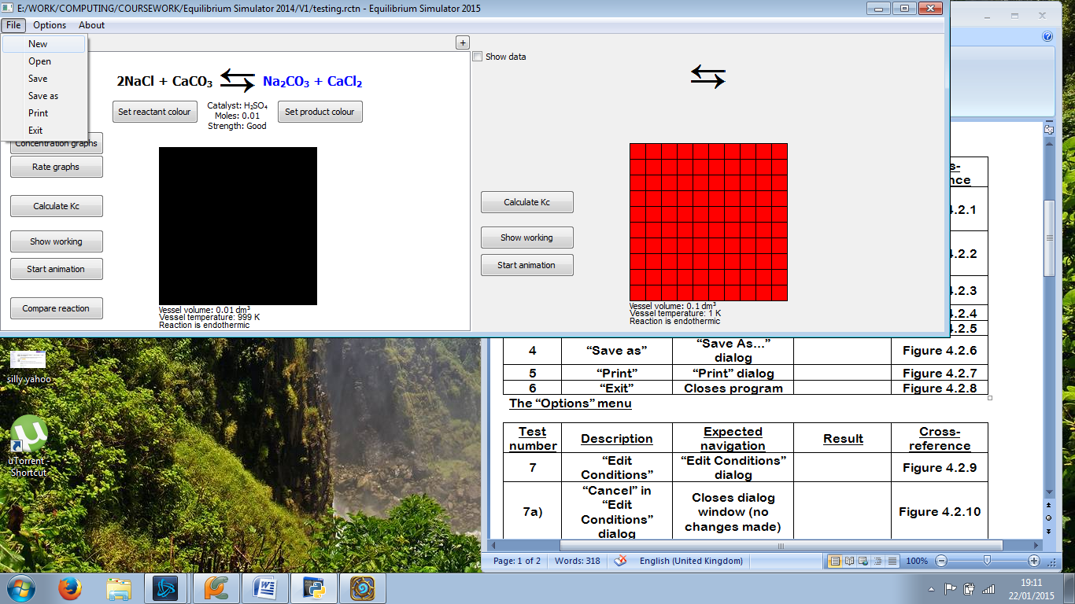 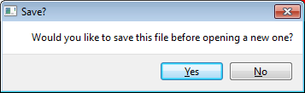

Figure 4.2.1: Popup box appears (right), asking user if they want to save

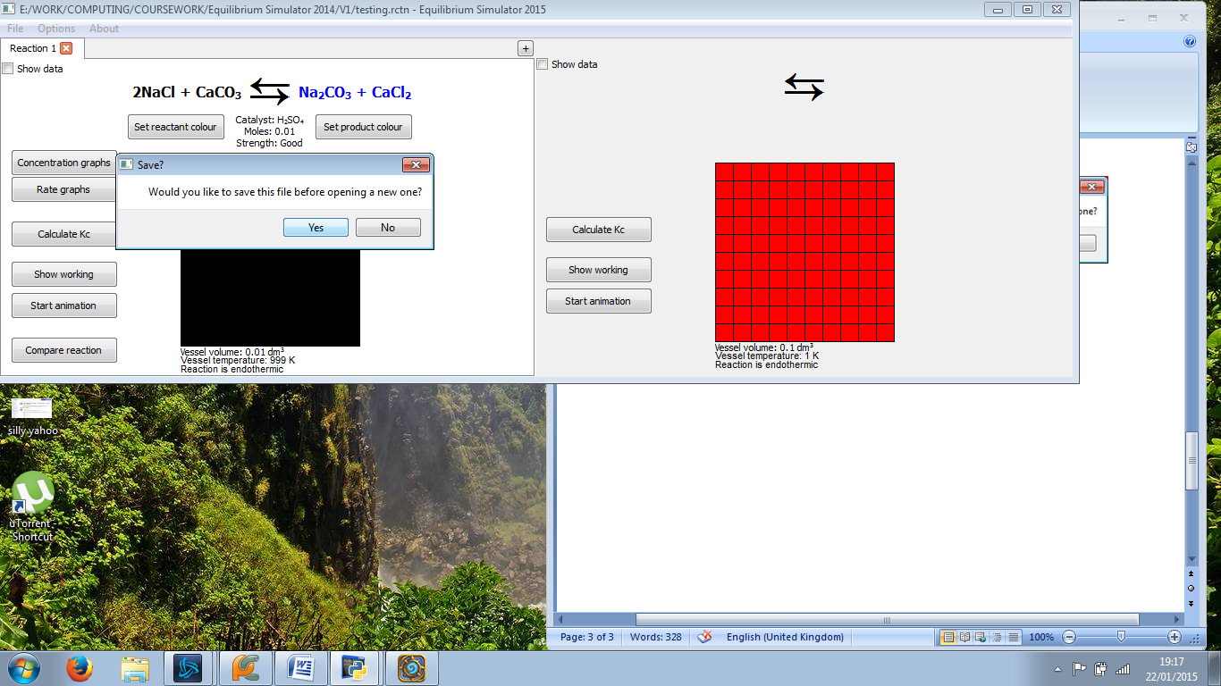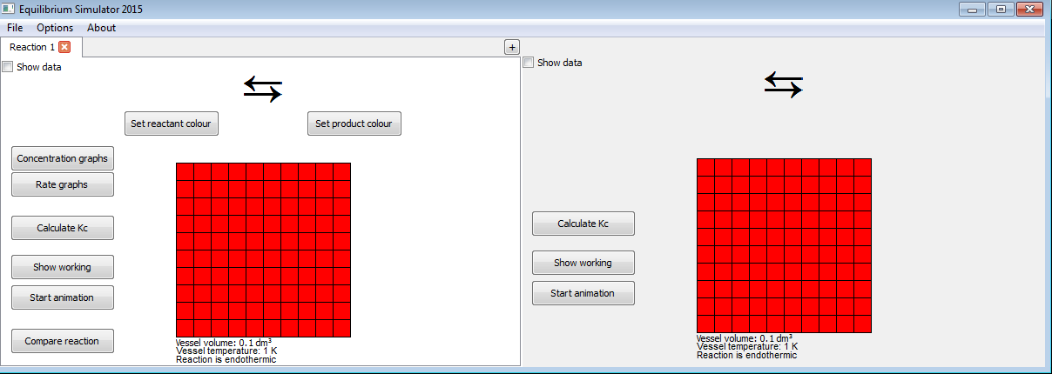

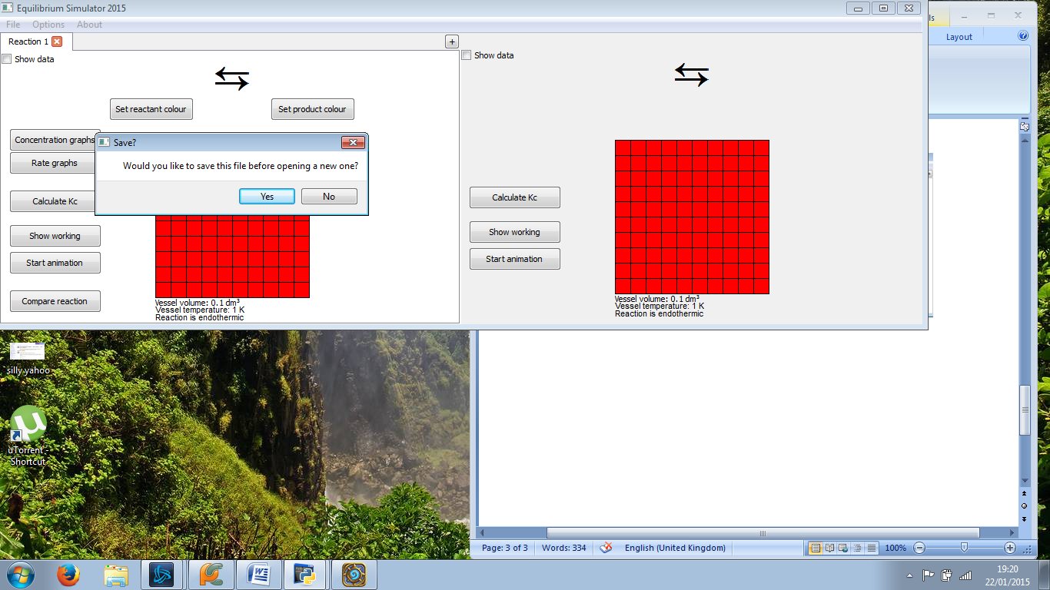

Figure 4.2.2: The file saves normally if a file has been saved before (top), but if not, the “Save As...” dialog is not opened (bottom)

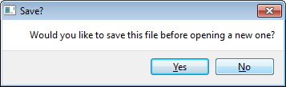

Figure 4.2.3: Popup box closes (left); left reaction window resets (right)

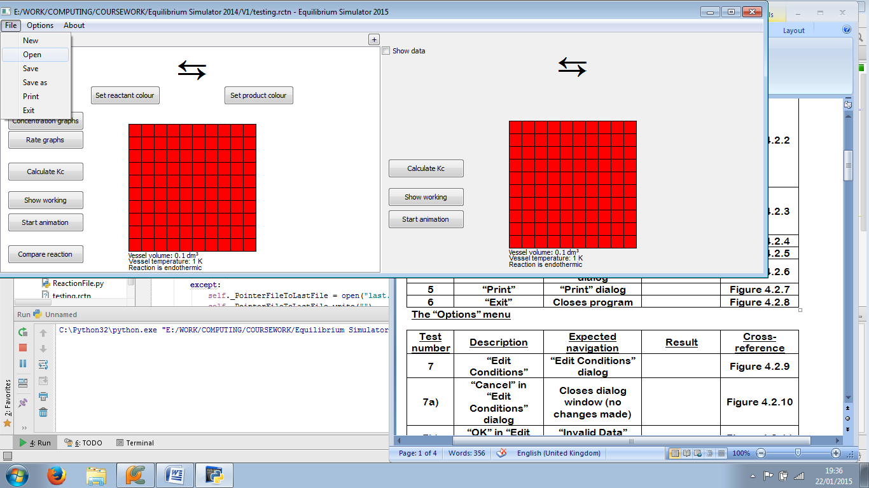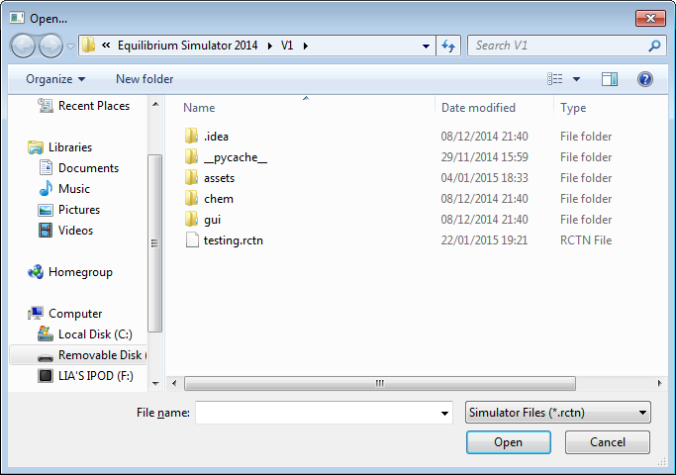

Figure 4.2.4: “Open...” dialog opens (right)

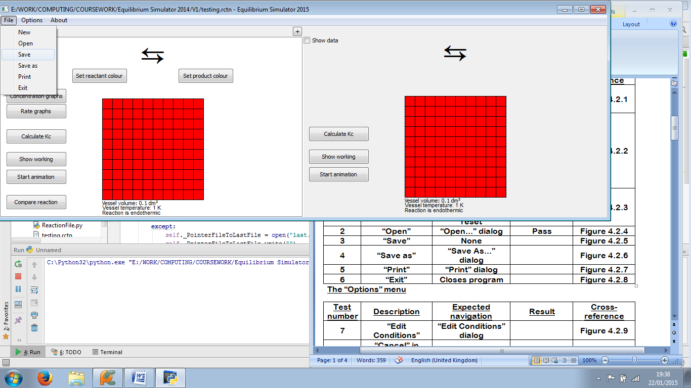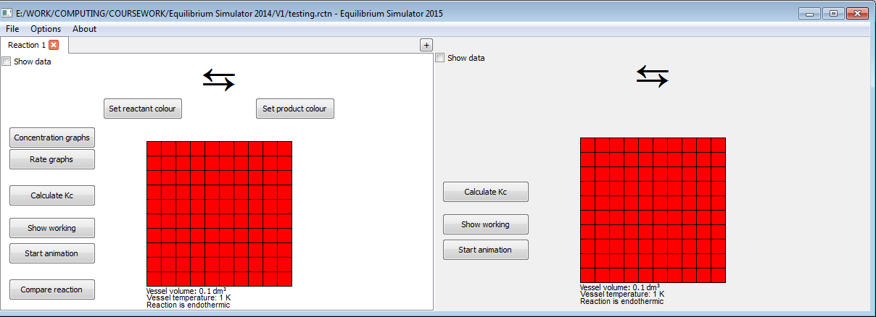

Figure 4.2.5: No navigation, as all that happens is the file saves

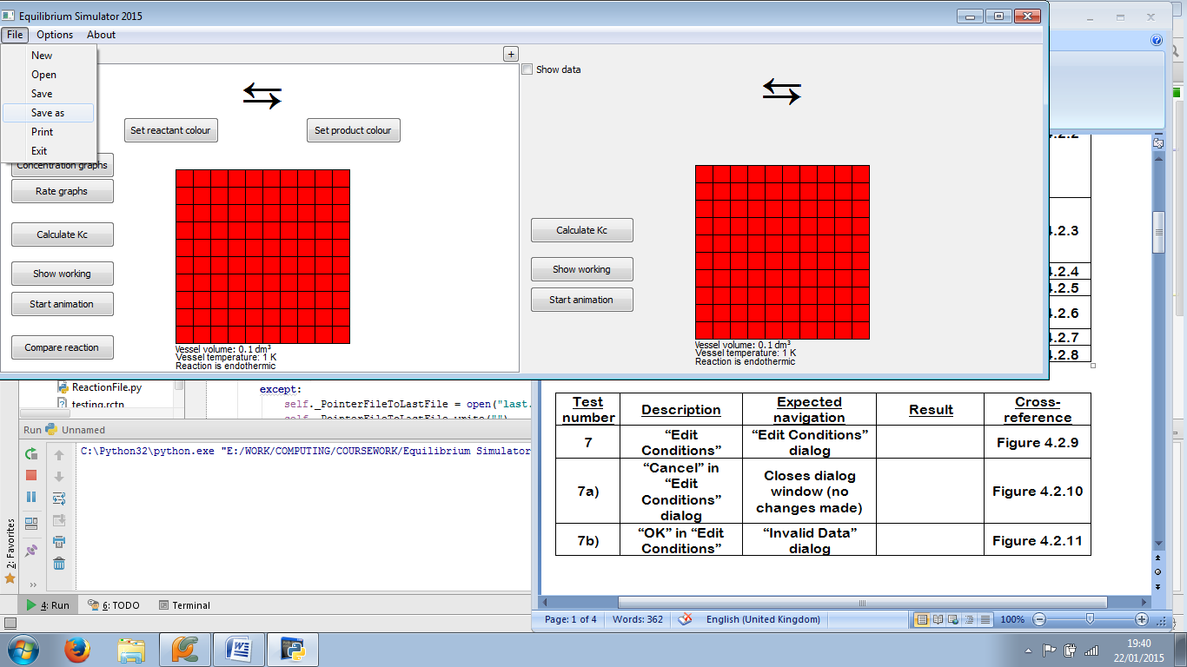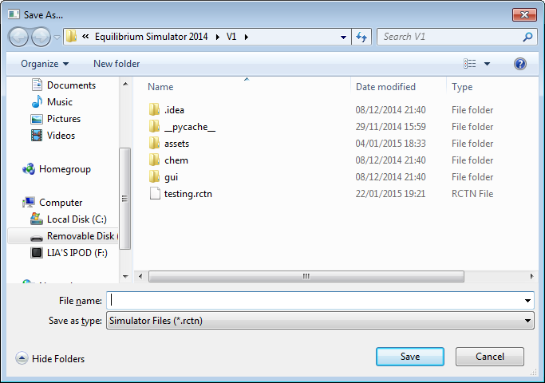

Figure 4.2.6: “Save As...” dialog opens (bottom)

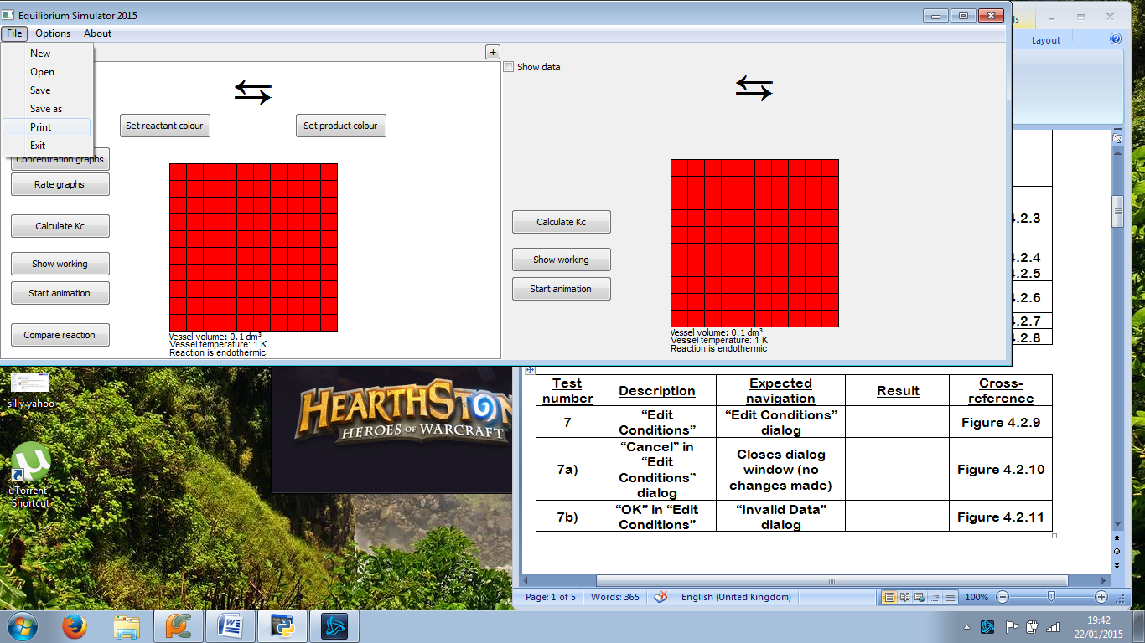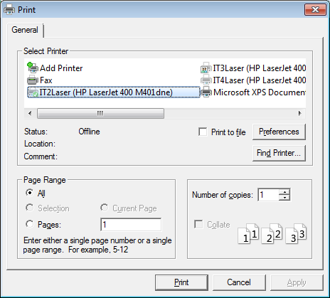

Figure 4.2.7: “Print” dialog opens (bottom)

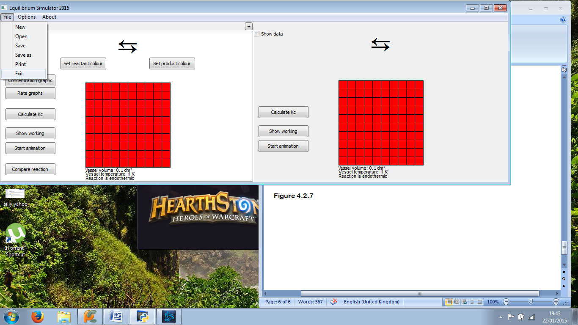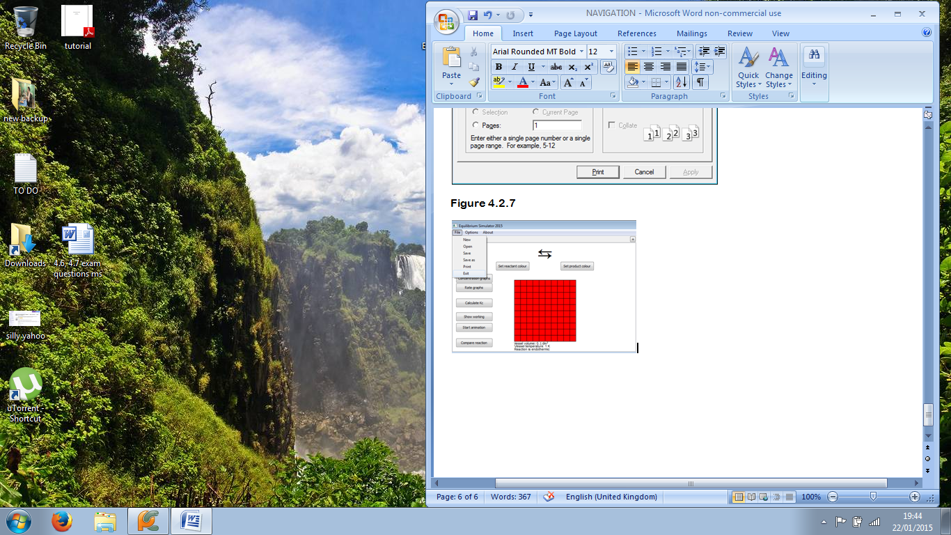

Figure 4.2.8: Program closes (right)

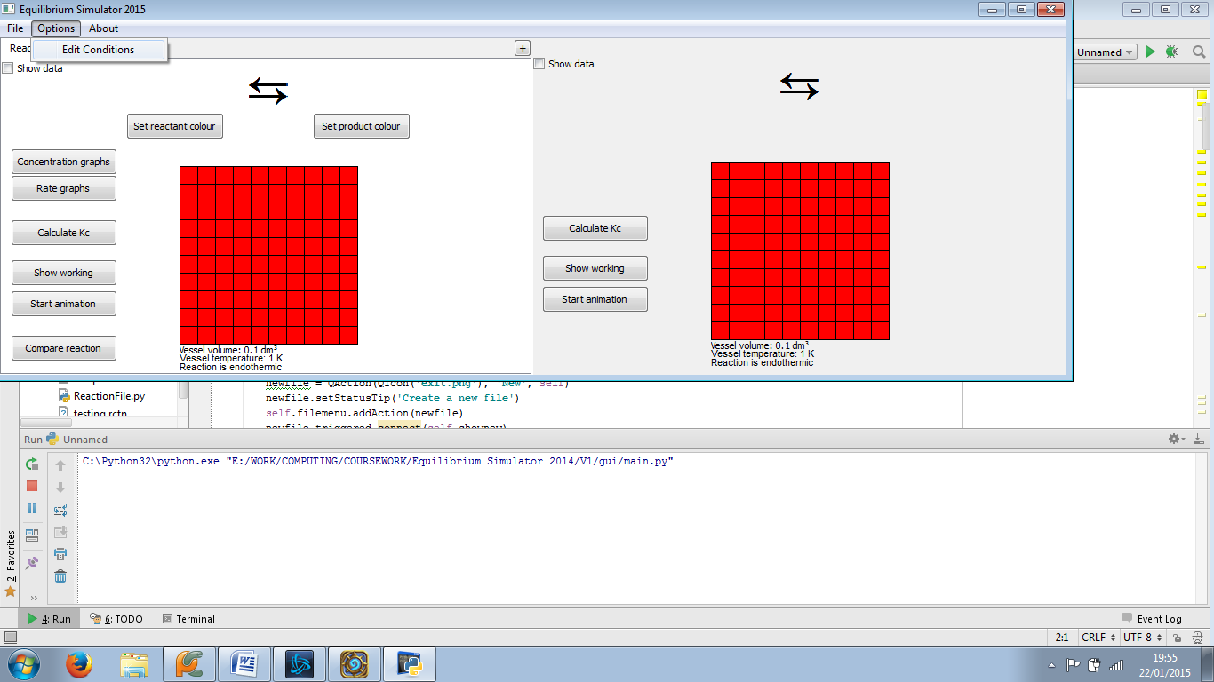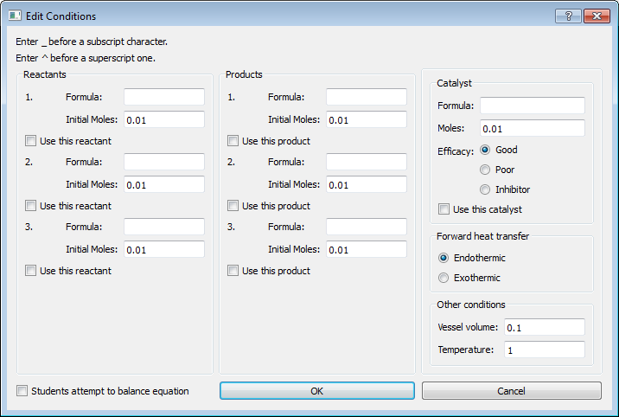

Figure 4.2.9: “Edit Conditions” dialog opens (right)

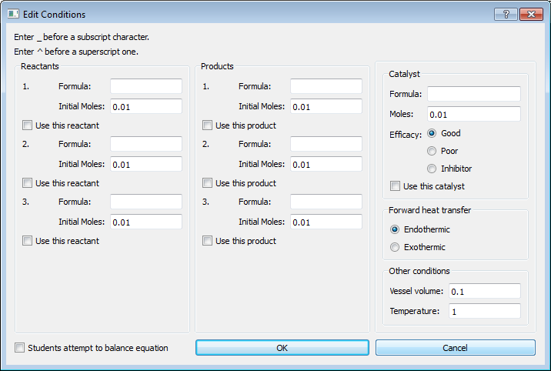

Figure 4.2.10: Dialog closes (right); focus changes to main window

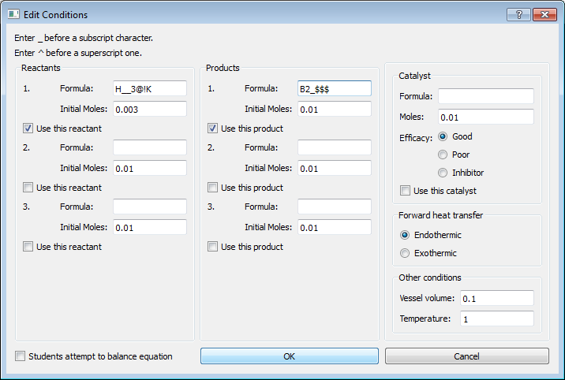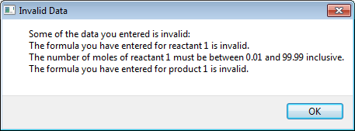

Figure 4.2.11: “Invalid Data” dialog opens (right)



Figure 4.2.12: “Invalid Data” dialog closes, but “Edit Conditions” dialog also closes (right)

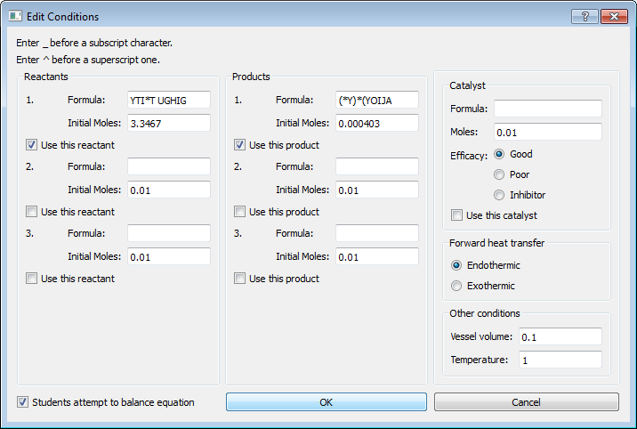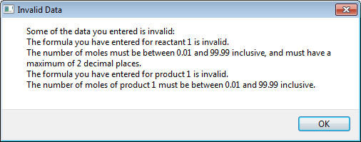

Figure 4.2.13: “Invalid Data” dialog opens (right)

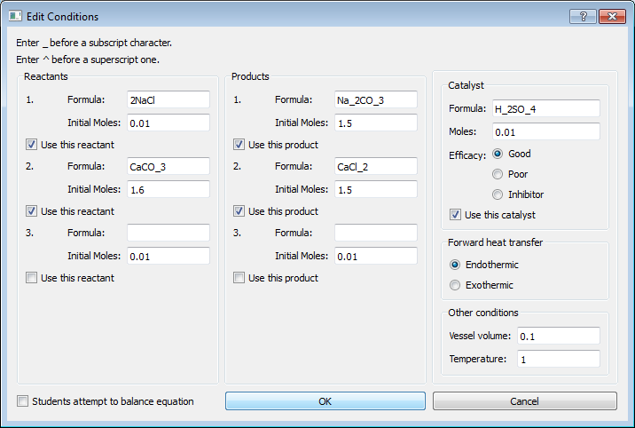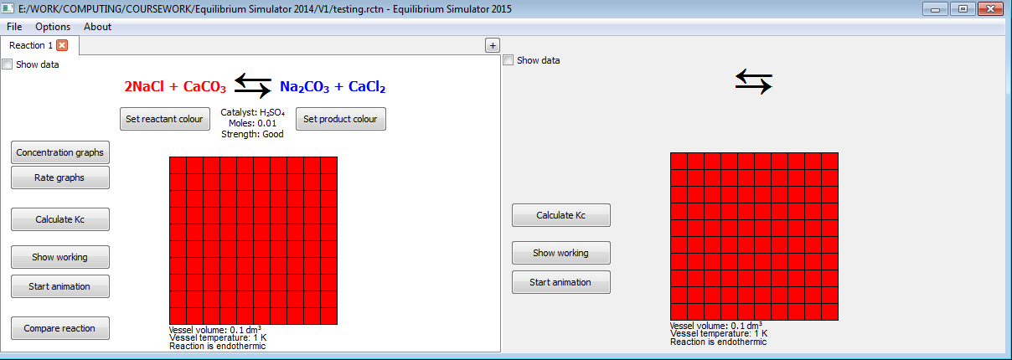

Figure 4.2.14: “Edit Conditions” window closes; reaction window updates (right)

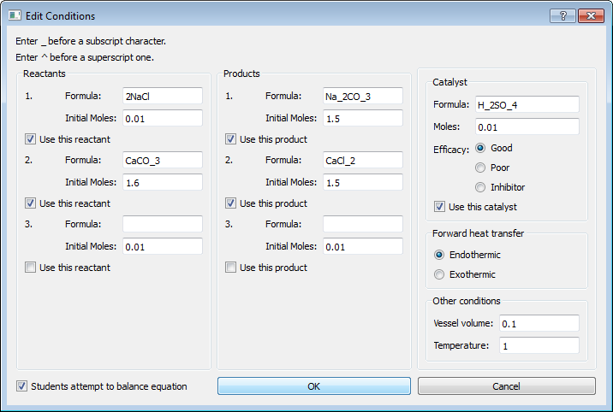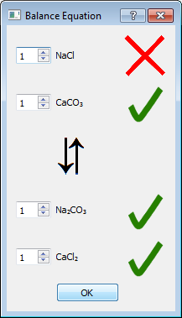

Figure 4.2.15: “Balance Equation” dialog opens (right)



Figure 4.2.16: “Balance Equation” and “Edit Conditions” windows close (right)

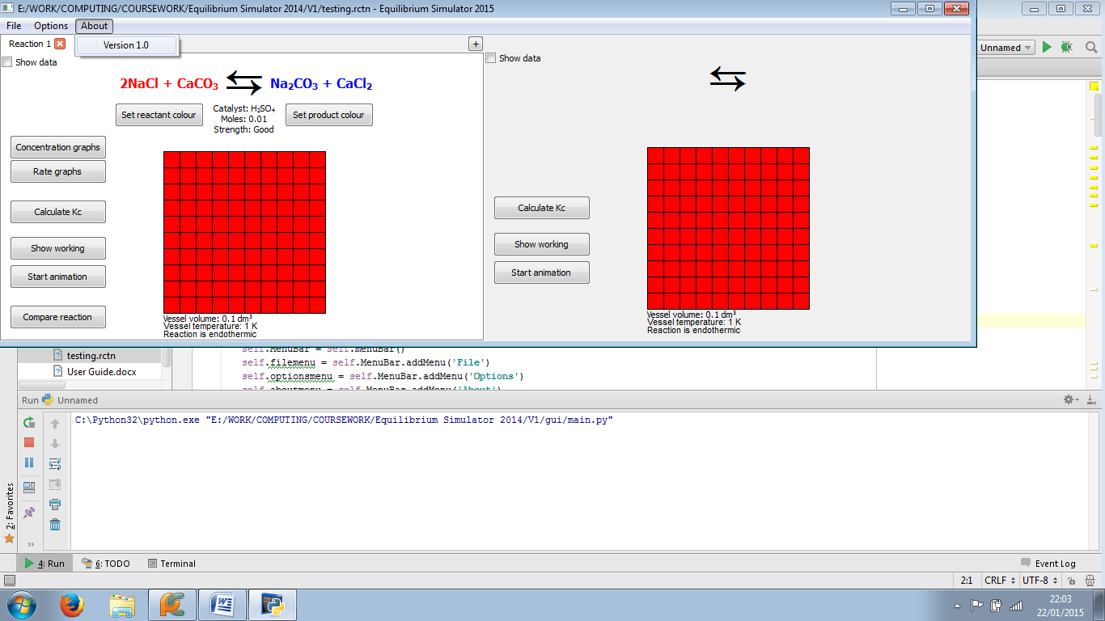

Figure 4.2.17: No navigation, as all that happens is the About menu closes

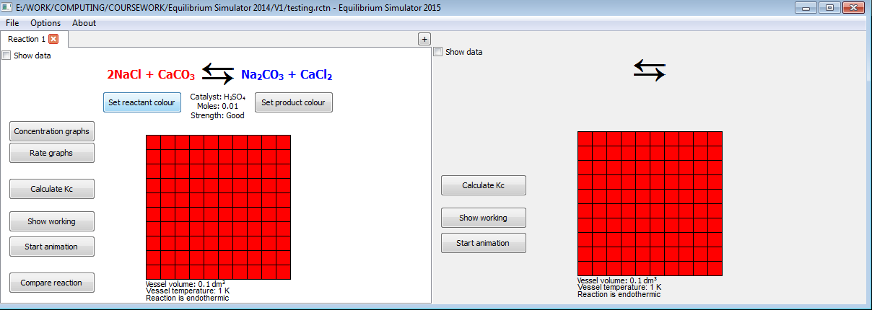 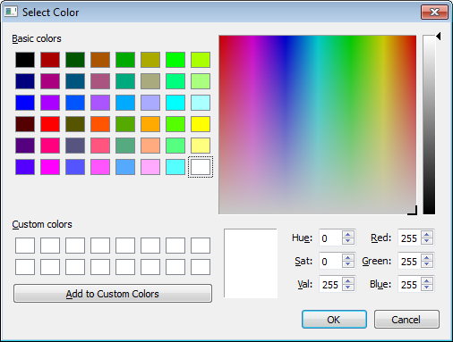

Figure 4.2.18: “Select Color” dialog opens (right)

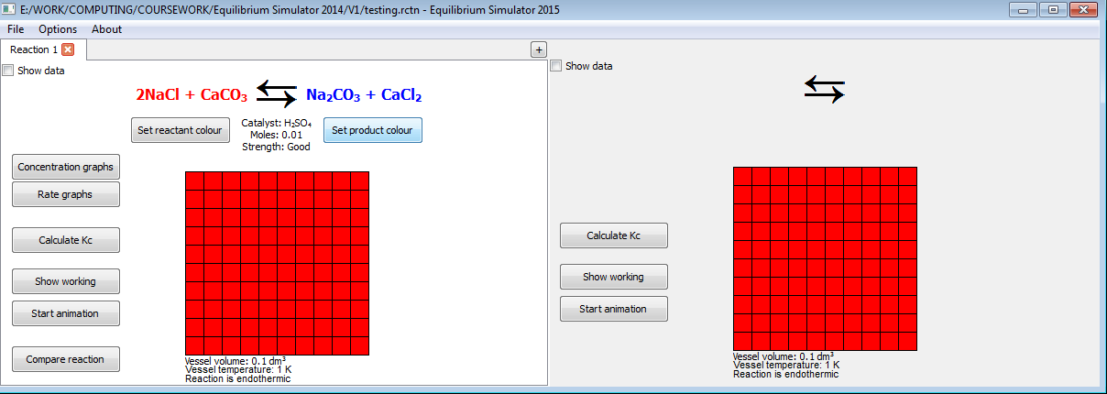 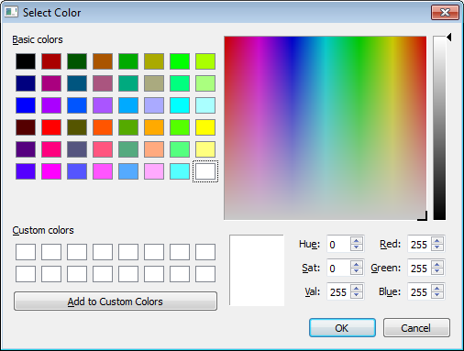

Figure 4.2.19: “Select Color” dialog opens (right)

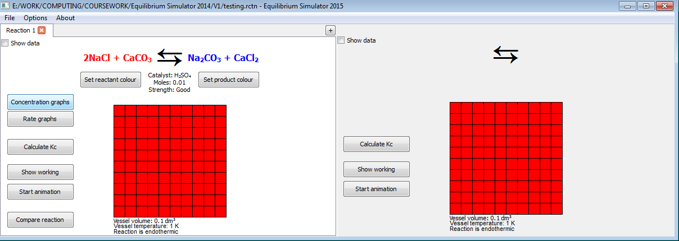 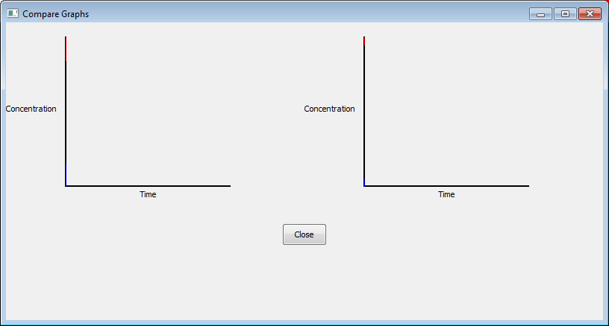

Figure 4.2.20: “Compare Graphs” window opens (right)

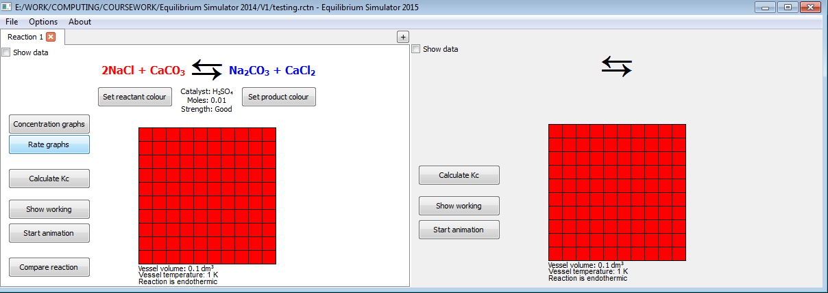 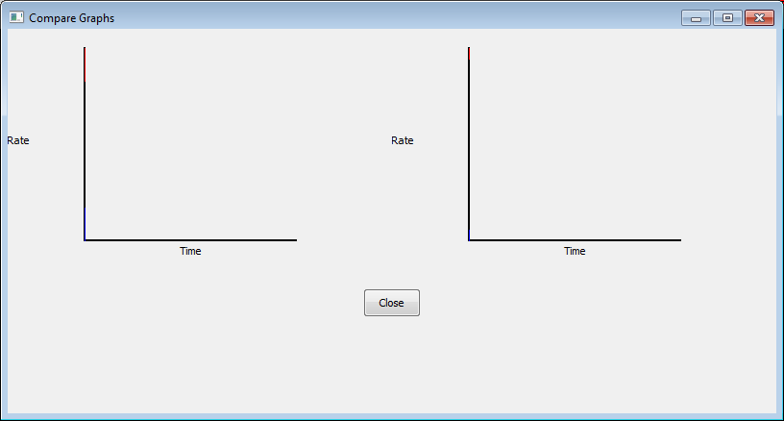

Figure 4.2.21: “Compare Graphs” window opens (right)

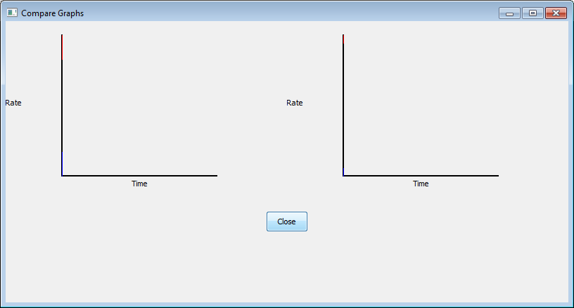 

Figure 4.2.22: “Compare Graphs” window closes; focus changes to reaction window again (right)

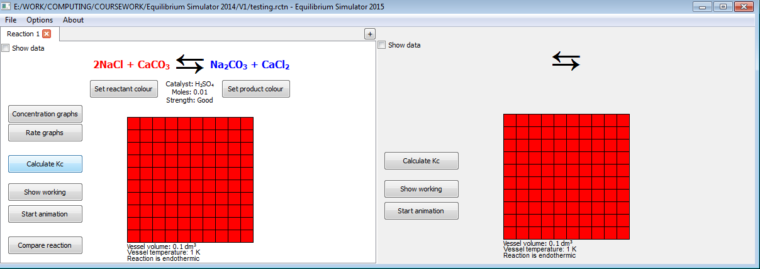 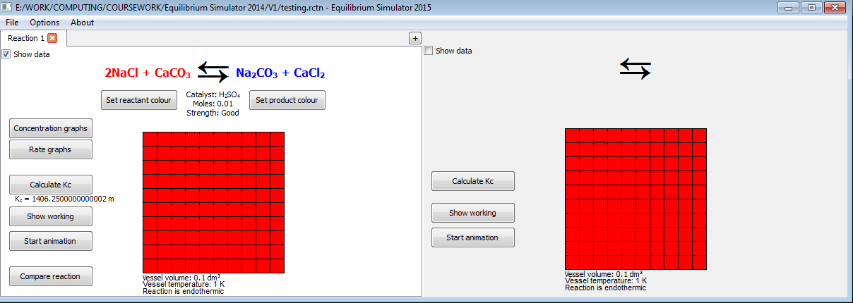

Figure 4.2.23: Value and units of Kc shown (right) so no navigation

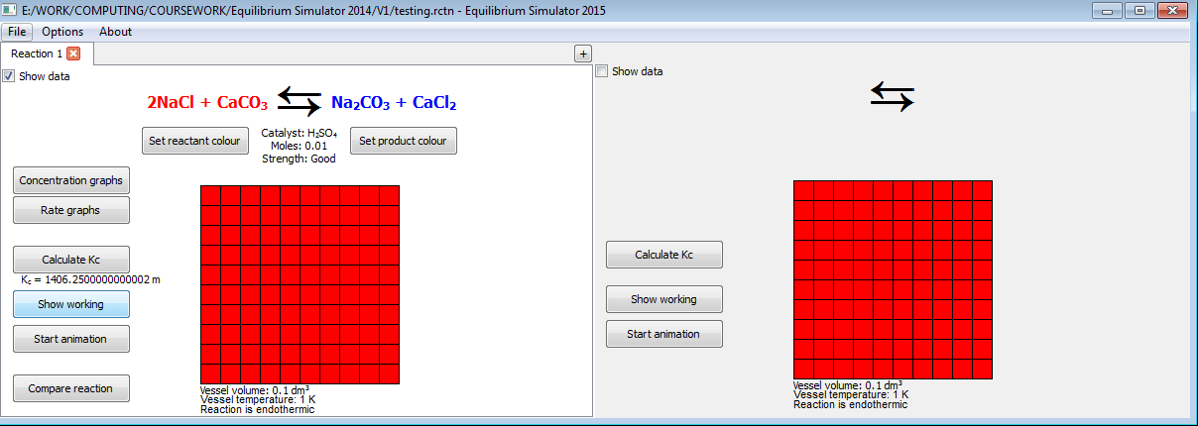 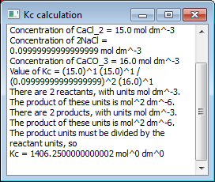

Figure 4.2.24: Small popup box appears (right), showing working in plain text

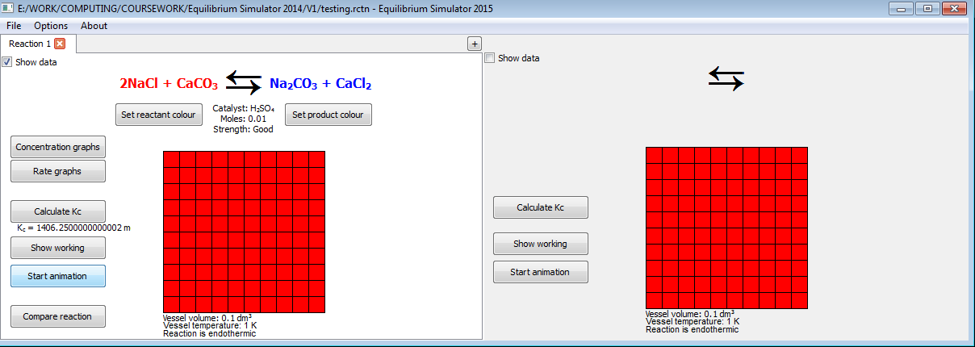 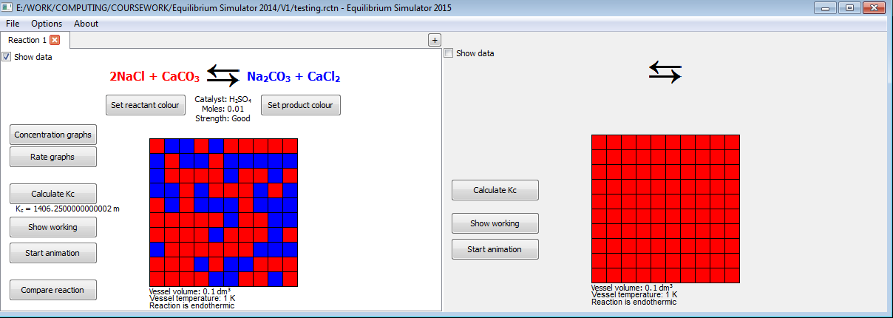

Figure 4.2.25: No navigation, as all that happens is animation begins

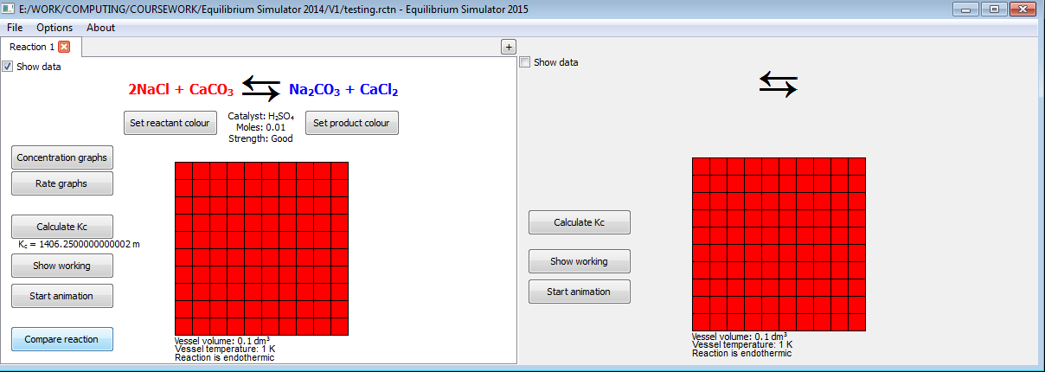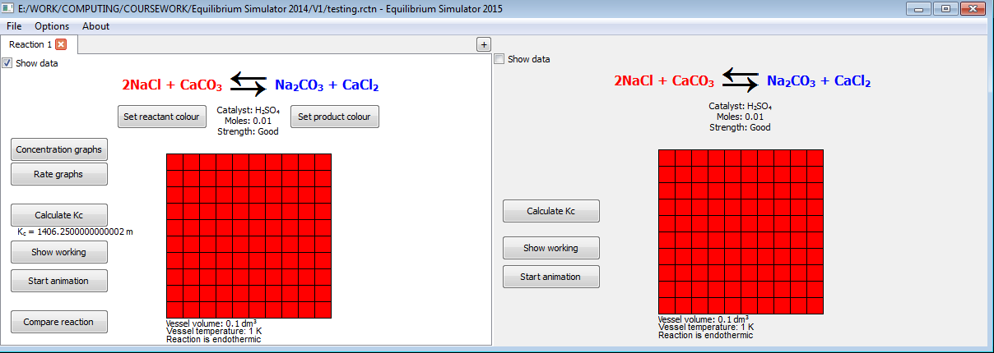  
Figure 4.2.26: No navigation, but right-hand-side reaction updated to a copy of left-hand-side reaction (bottom)

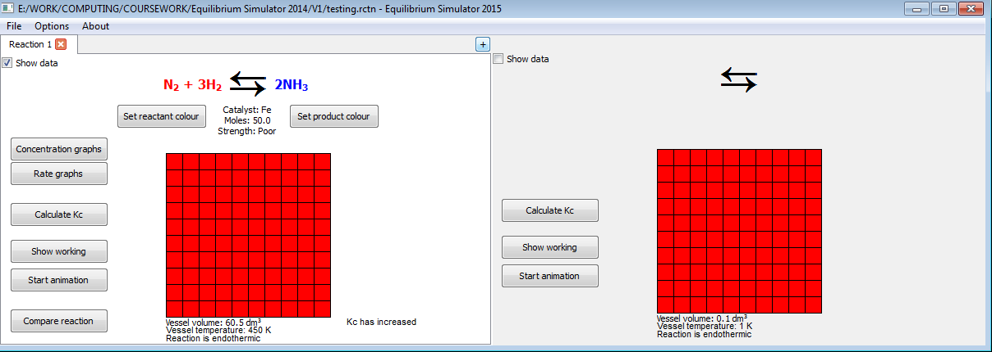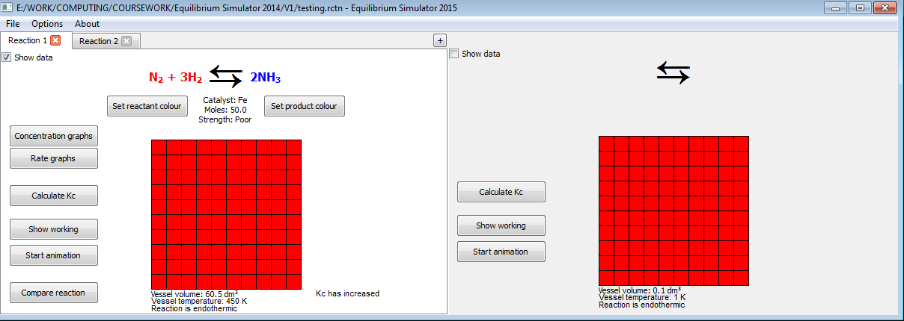

Figure 4.2.27: No navigation, but a new reaction tab is added (right)

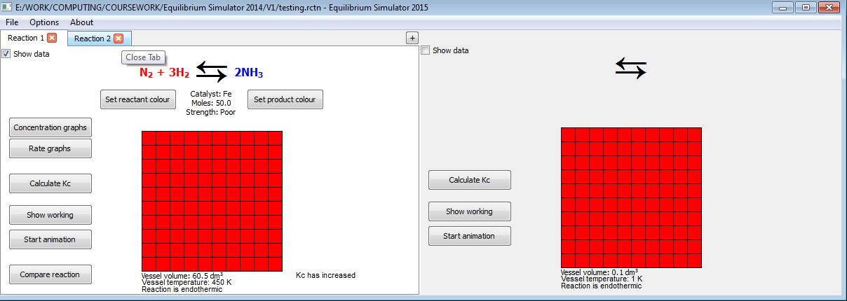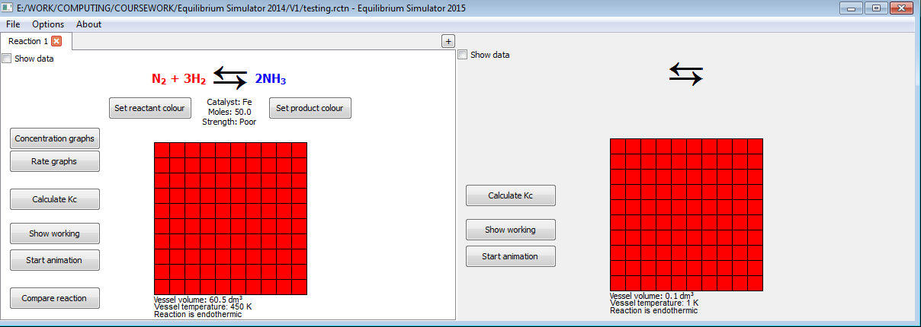

Figure 4.2.28: No navigation, but the reaction tab closes (right)

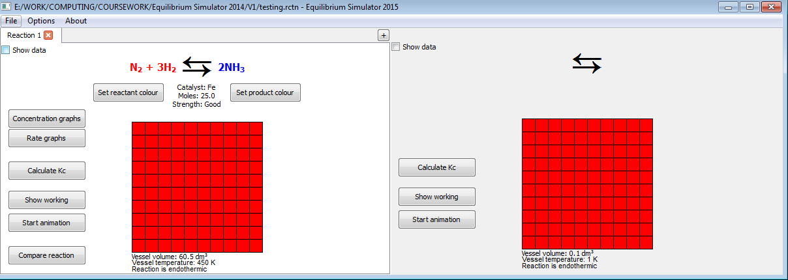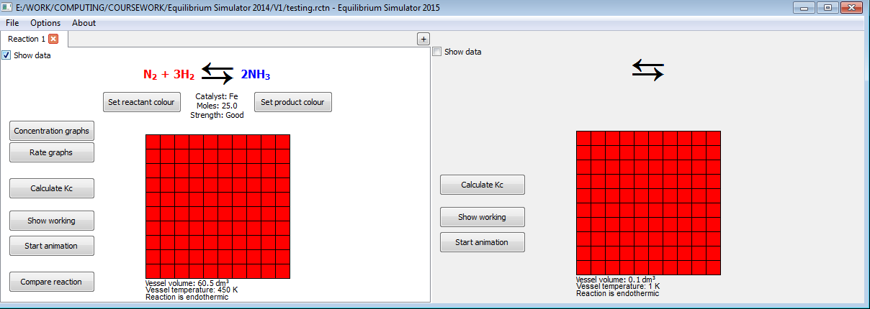

Figure 4.2.29: Toggling the check box toggles the appearance of certain data (not set to appear in this example), so no navigation takes place

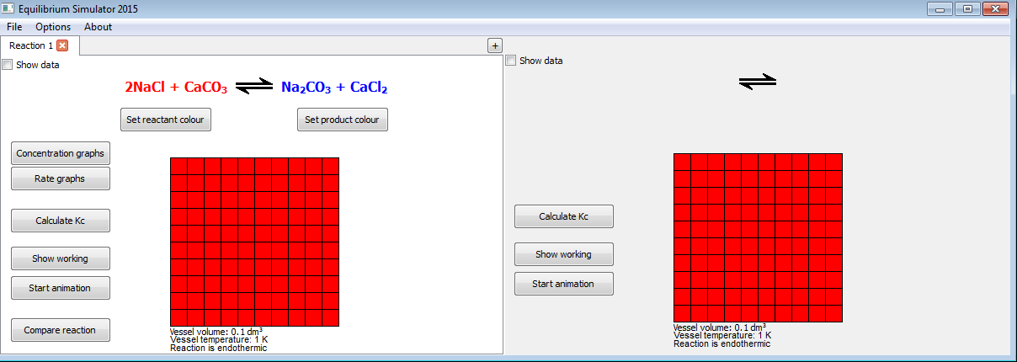 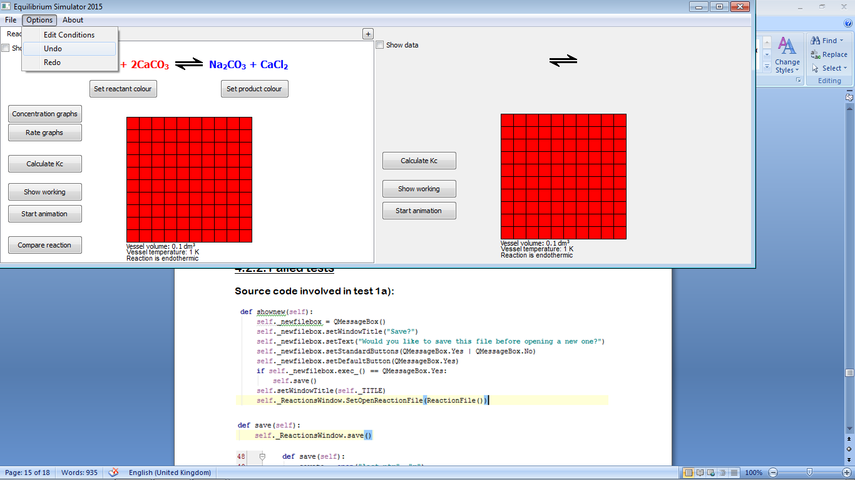

Figure 4.2.30: After a change is made (top right: a 2 is added to CaCO3), when “Undo” is pressed, the change is removed (bottom left)

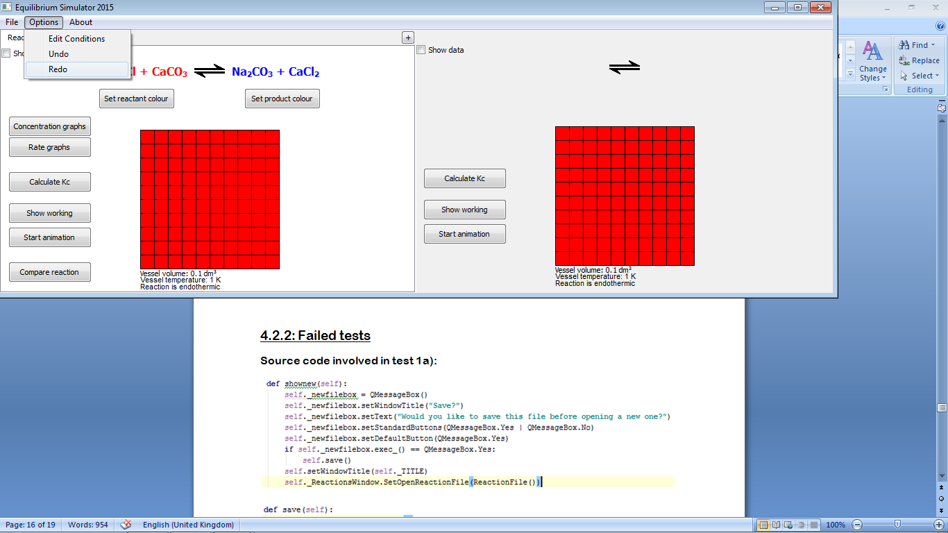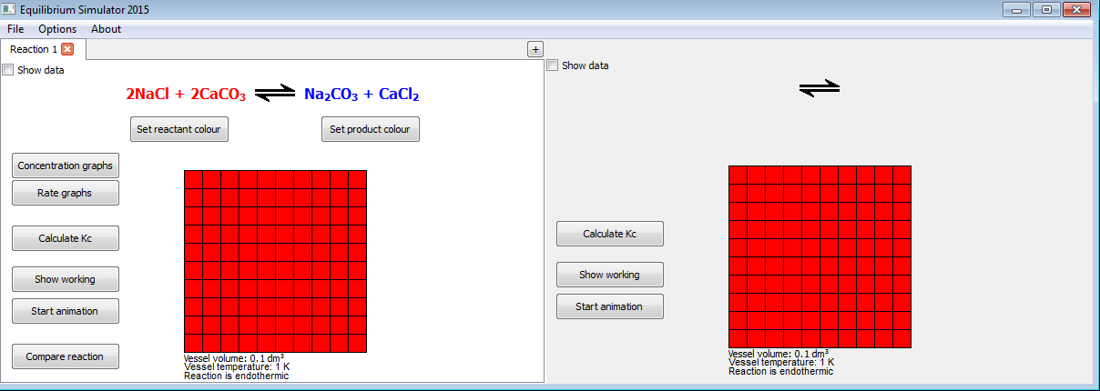

Figure 4.2.31: When “Redo” is pressed, the 2 (see Figure 4.2.30, top right) reappears (right), showing that the undone reaction has been restored

4.2.2: Failed tests

Source code involved in test 1a):

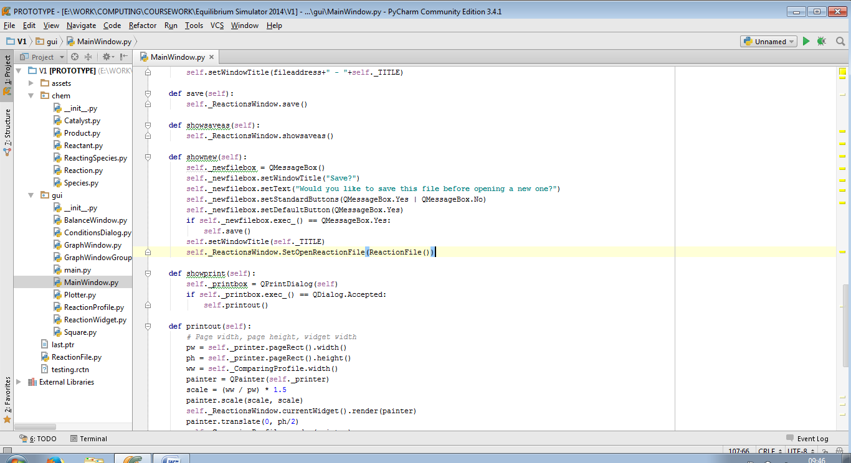

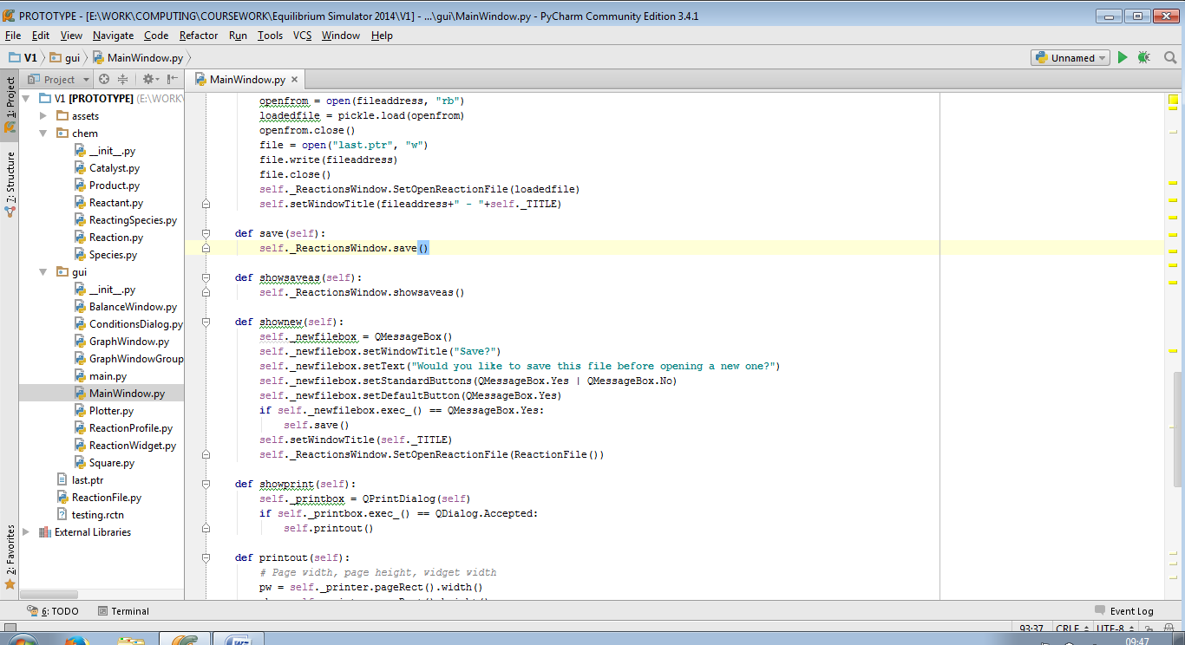

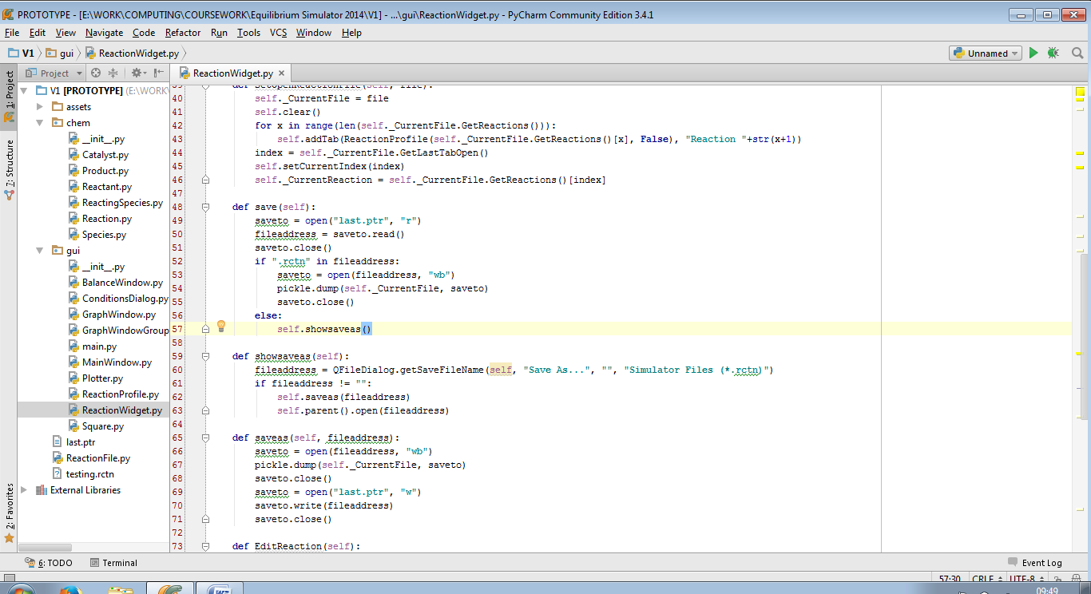

In the second save() procedure, the program checks if the last file opened was a .rctn file, and if so, saves to that file. However when a new file is opened, the address of the last file opened is not changed, so the new file overwrites the old one. This can be solved by editing the shownew() procedure to remove the path of the last open file, so that the “Save As...” dialog is shown.

Amended source code:

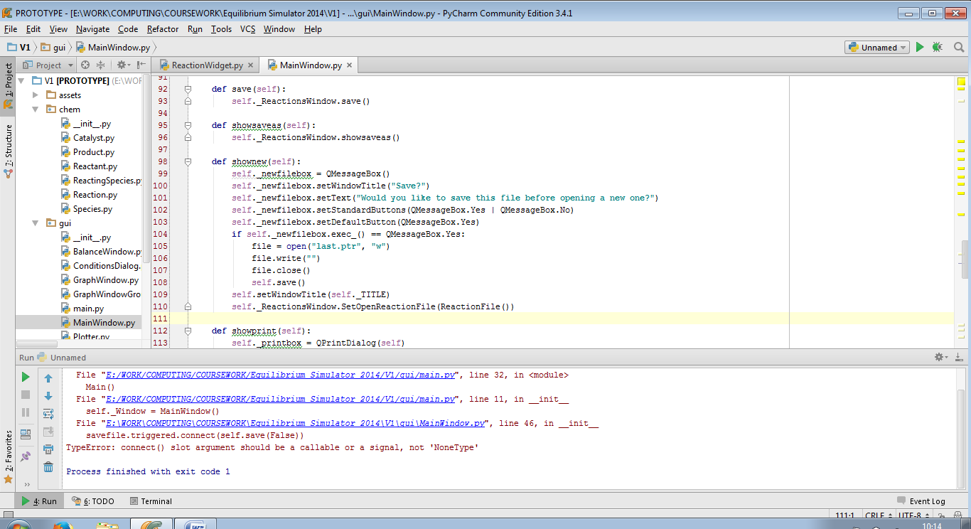

The code now passes test 1a):

|  |  |  |  |
| --- | --- | --- | --- |
| 1a) | On clicking “Yes” in popup box | Pass | Figure 4.2.32 |

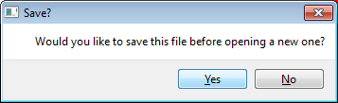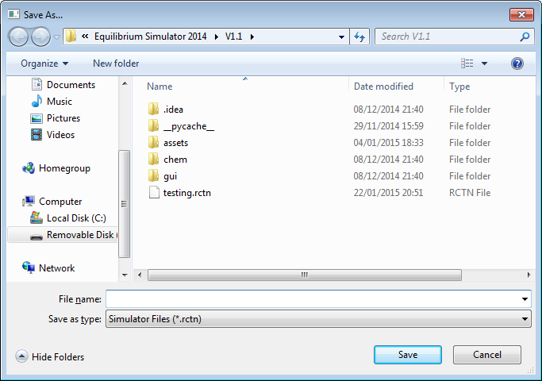

Figure 4.2.32: If nothing is saved before, the “Save As...” dialog is opened (right)

This is the source code involved in test 7b)i):

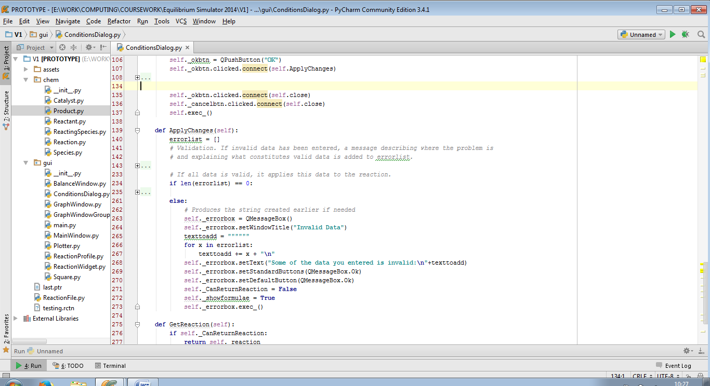

Here, the ‘signal’ of clicking the “OK” button is connected to two ‘slot’ procedures: ApplyChanges() and close(), which is a built-in method for closing widgets. This means that whether or not the changes are valid, the “Edit Conditions” dialog will close. This can be solved by only connecting the “OK” button to the ApplyChanges() slot, and only calling the close() method if all input data is valid.

Amended source code:

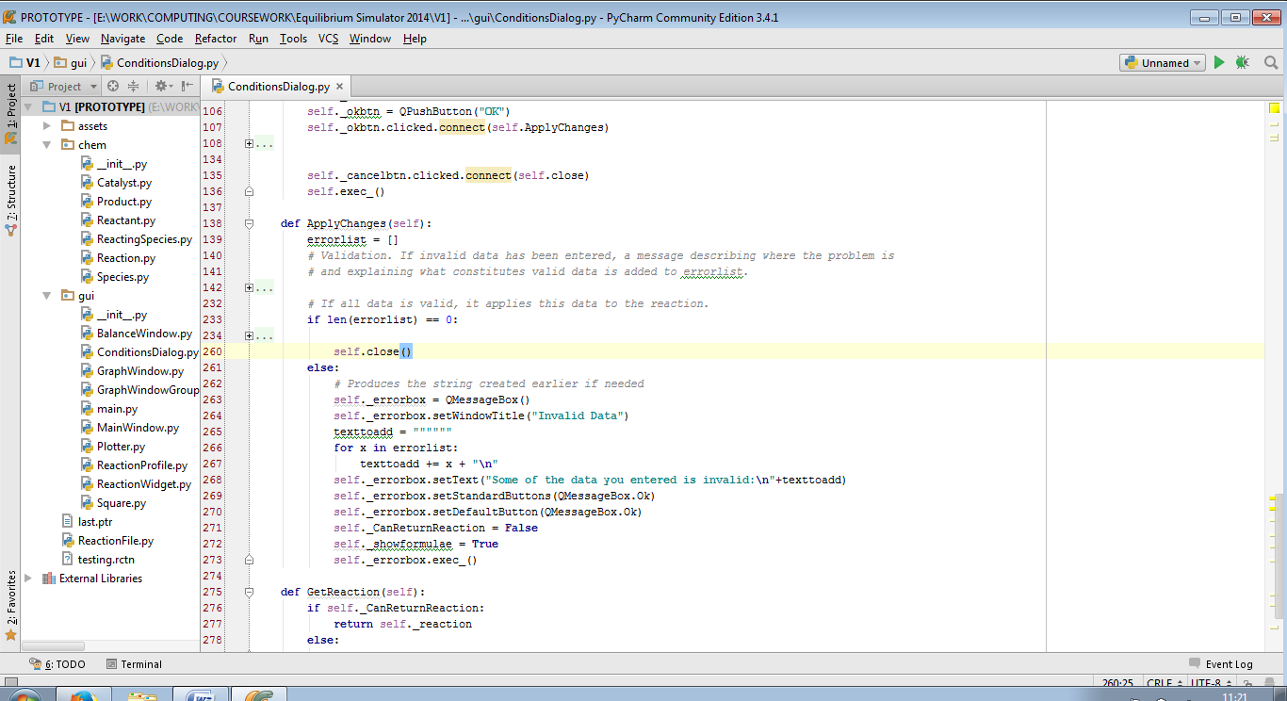

The code now passes test 7b)i):

|  |  |  |  |
| --- | --- | --- | --- |
| 7b)i) | On clicking “OK” in “Invalid Data” dialog | Pass | Figure 4.2.33 |

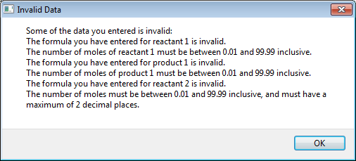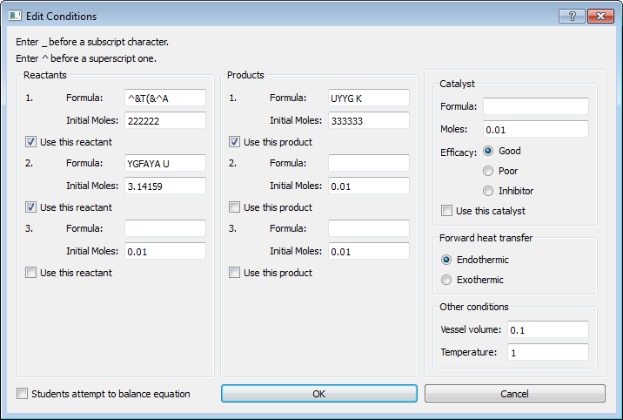

Figure 4.2.33: Dialog (top) closes; focus goes back to “Edit Conditions” dialog (bottom)